PROJECT DEVELOPMENT DELIVERY OF SPRINT-3

|  |  |
| --- | --- |
| Date | 08 November 2022 |
| Team ID | PNT2022TMID10555 |
| Project Name | Project – Real-Time River Water Quality  Monitoring and Control System |

Real time monitoring of water quality by using IoT integrated Big Data Analytics:

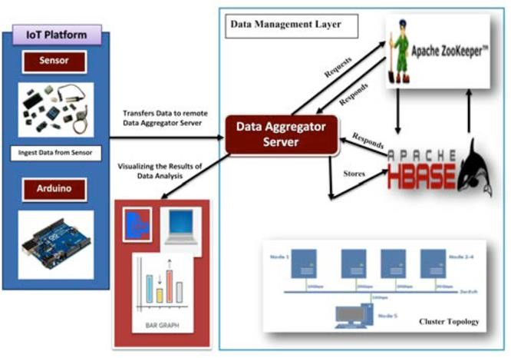

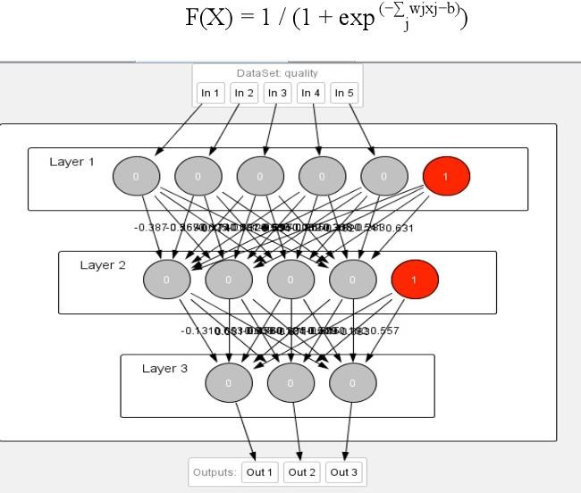

. Neural network models in Big Data Analytics and water quality management